NAME: VISHWAS M

SRN: PES2UG20CS390

SEC: F

SUBJECT: OPERATION SYSTEM LAB

WEEK: 1

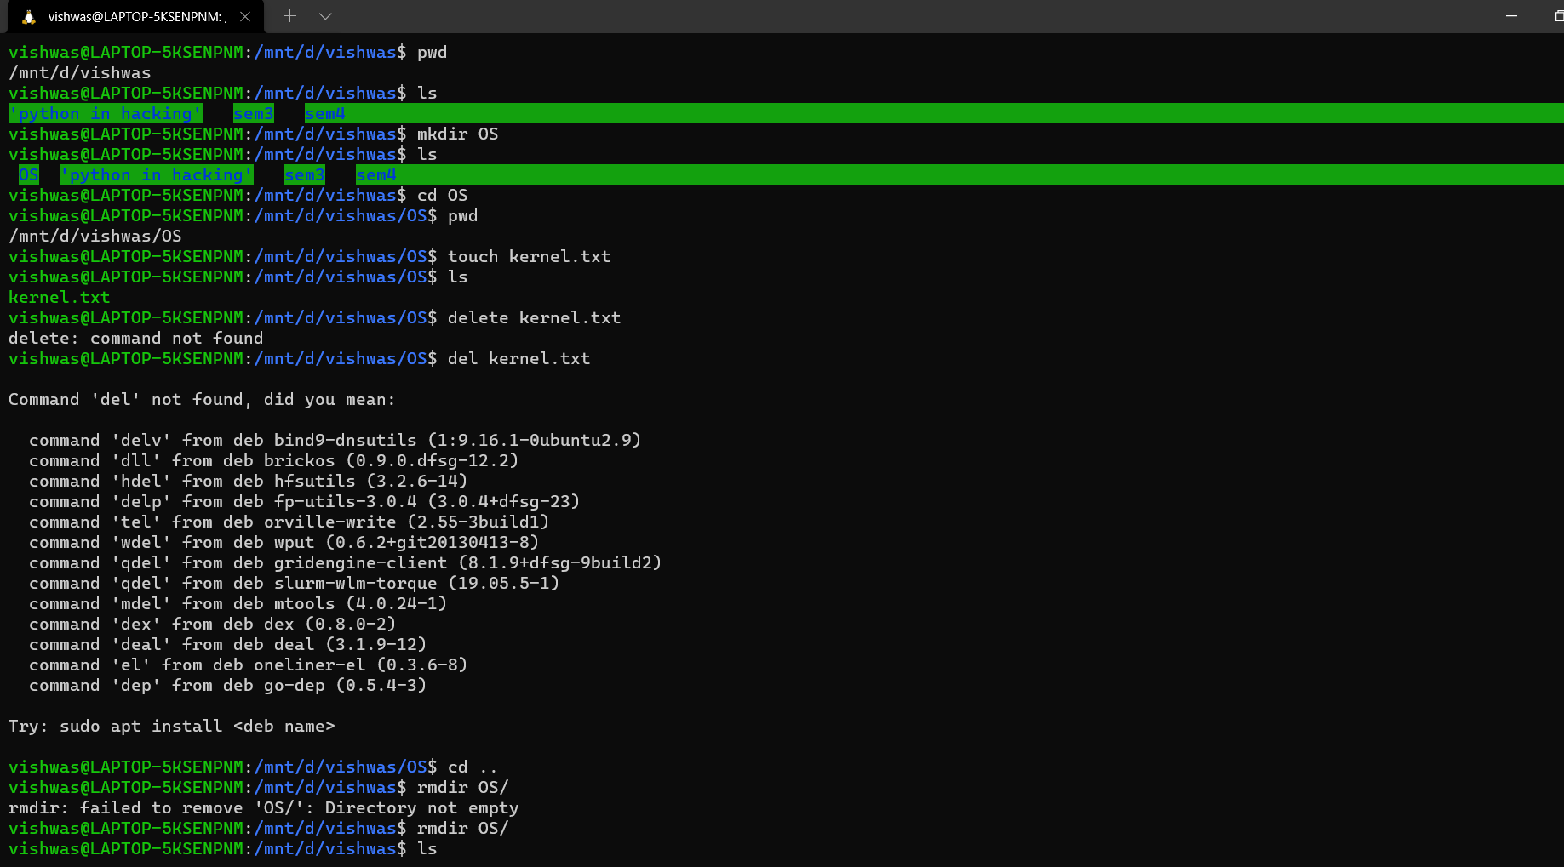***COMMANDS USED IN LINUX:***

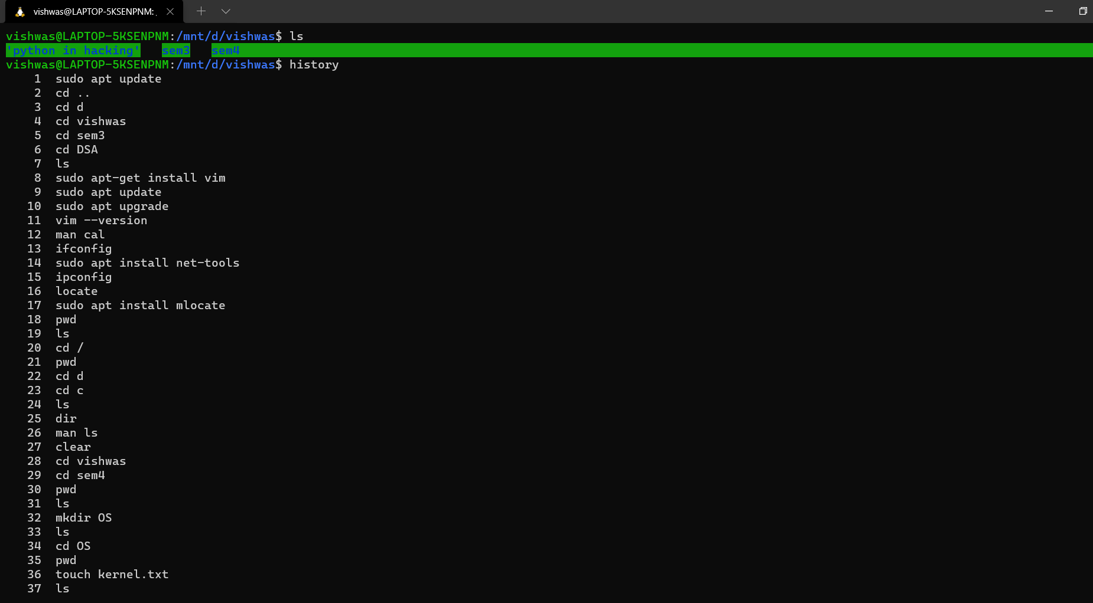

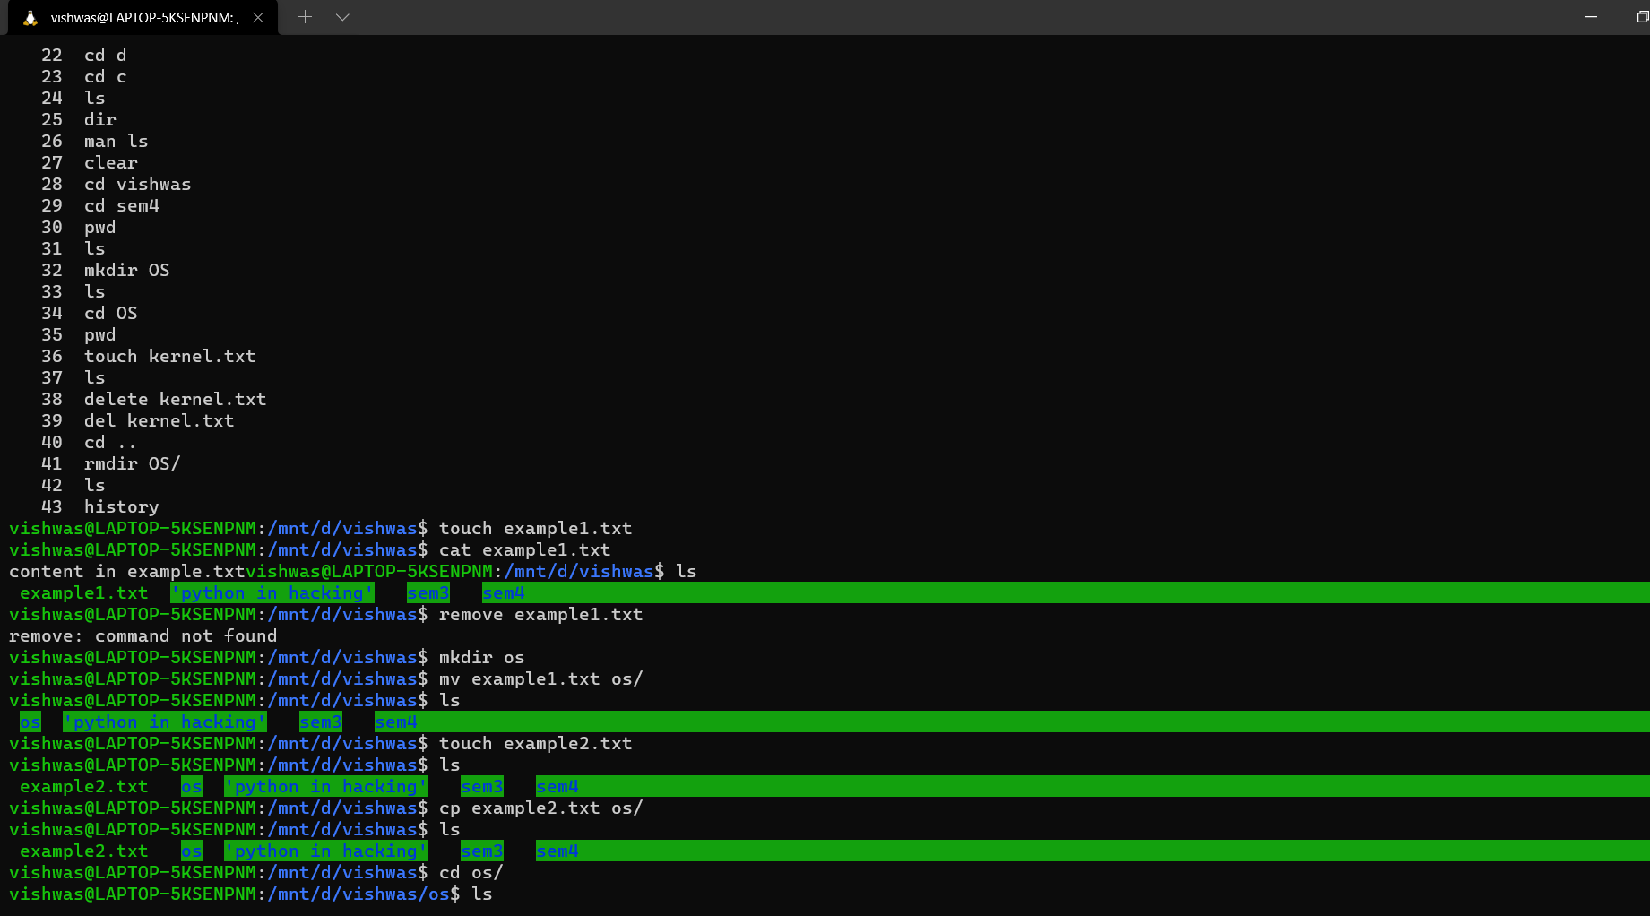

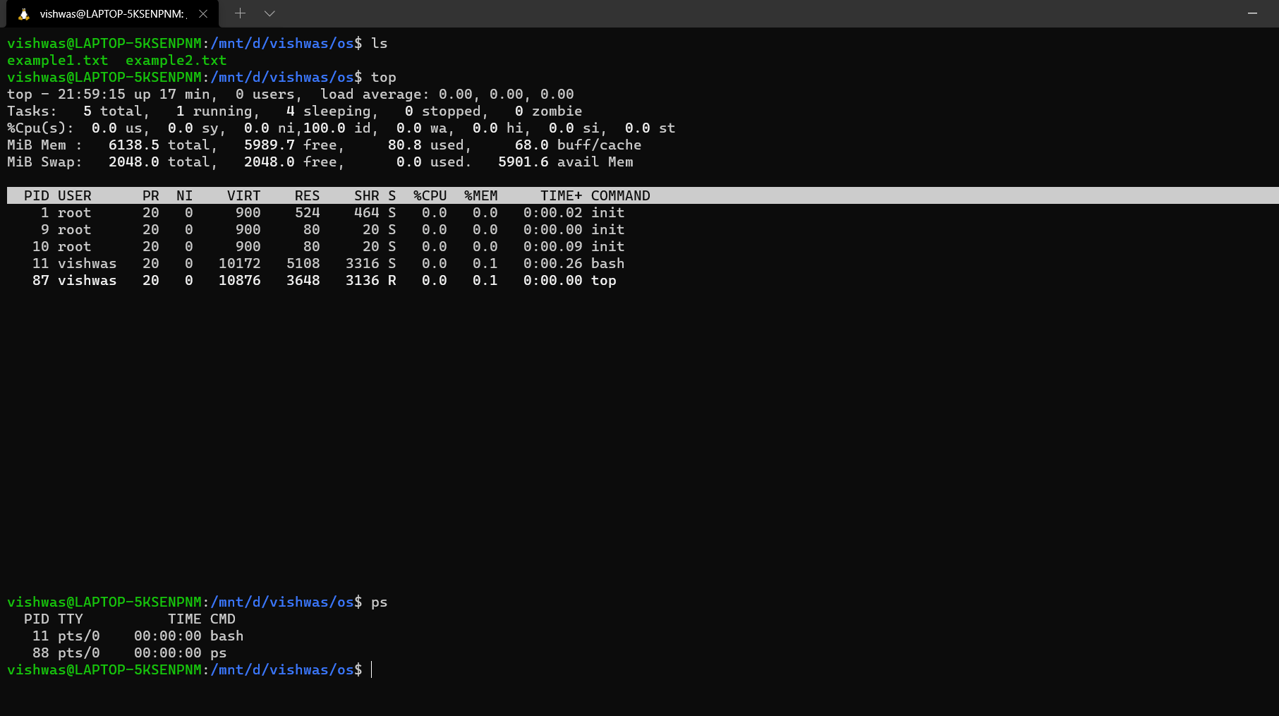

LIST OF COMMANDS USED:

1. Ls
2. pwd
3. cd
4. cd /
5. cd ..
6. mkdir
7. touch
8. mv
9. cp
10. cat
11. top
12. ps
13. rmdir
14. clear
15. history

***STEPS INVOLVED IN INSTALLING LINUX***:

You can now install everything you need to run Windows Subsystem for Linux (WSL) by entering this command in an administrator PowerShell or Windows Command Prompt and then restarting your machine.

wsl --install

This command will enable the required optional components, download the latest Linux kernel, set WSL 2 as your default, and install a Linux distribution for you (Ubuntu by default, see below to change this). The first time you launch a newly install led Linux distribution, a console window will open and you' l be asked to wait for files to de-compress and be stored on your machine. A l future launches should take less than a second.

To update from WSL 1 to WSL 2 on previously insta led Linux distributions, use the command: wsl --set-version <distro name> 2 replacing <distro name> with the name of the Linux distribution that you want to update. For example, wsl --set-version Ubuntu-20.04 2 wi l set your Ubuntu 20.04 distribution to use WSL 2. You may also need to enable the virtual machine optional component used by WSL 2 and kernel package if you haven't already done so. New Linux insta lations wi l be set to WSL 2 by default, but the insta l the wsl --set-version command can be used to wsl -l -v . downgrade from WSL 2 to WSL 1 as wel. To see whether your Linux distribution is set to WSL 1 or WSL 2, use the command: To learn more, see the Command reference for WSL for a list of WSL commands, Comparing WSL 1 and WSL 2 for guidance on which to use for your work scenario, or Best practices for setting up a WSL development environment for general guidance on setting up a good development workflow with WSL.

There are several ways to run your Linux distributions once insta led:

1. Install Windows Terminal (Recommended) building your own custom (Recommended) Using Windows Terminal supports as many command lines as you would like to install and enables you to open them in multiple tabs or window panes and quickly switch between multiple Linux distributions or other command lines (PowerShell, Command Prompt, PowerShell, Azure CLI, etc). You can fully customize your terminal with unique color schemes, font styles, sizes, background images, and custom keyboard shortcuts. Learn more.

2. You can directly open your Linux distribution by visiting the Windows Start menu and typing the name of your insta led distributions. For example: "Ubuntu". This will open Ubuntu in it's own console window.

3. From Windows Command Prompt or PowerShell, you can enter the name of your installed distribution. For example: ubuntu

4. From Windows Command Prompt or PowerShell, you can open your default Linux distribution inside your current command line, by entering: wsl.exe .

5. From Windows Command Prompt or PowerShell, you can use your default Linux distribution inside your current command line, without entering a new one, by entering: wsl [command] . Replacing [command] with a WSL command, such as: wsl -l -v to list installed distributions or wsl pwd to see where the current directory path is mounted in wsl. From PowerShell, the command get-date will provide the date from the Windows file system and wsl date will provide the date from the Linux file system. The method you select should depend on what you're doing. If you've opened a WSL command line within a Windows Prompt or PowerShell window and want to exit, enter the command:exit.